**Disney+HotStar Data Analysis**

Tamizhsudar N

MBE9

### **Introduction**

### This project focuses on providing an in-depth analysis of Disney+Hotstar's movie catalogue, with the aim of uncovering critical trends and insights. Disney+Hotstar, a leading streaming platform in India and several other markets, offers a diverse range of content, including movies, TV shows, live sports, and original programming. As the platform continues to grow its subscriber base, understanding the composition of its movie library becomes vital to better aligning content strategy with audience preferences. By examining key aspects such as genre distribution, running time, release year trends, and age ratings, this analysis seeks to highlight patterns that could enhance viewer engagement and improve decision-making around content creation, curation, and distribution.

Through a series of visualisations, the analysis delves into the streaming patterns on Disney+ Hotstar, revealing shifts in content preferences, variations in movie lengths, and the dominance of certain genres. The insights gained are valuable not only for content strategy but also for audience segmentation, helping Disney+ Hotstar tailor its recommendations to meet the specific needs of its diverse viewer base. The study also explores the role of age ratings and running time, which are critical for designing marketing campaigns, improving user retention, and enhancing the overall viewer experience on the platform.

**VISUALISATIONS**

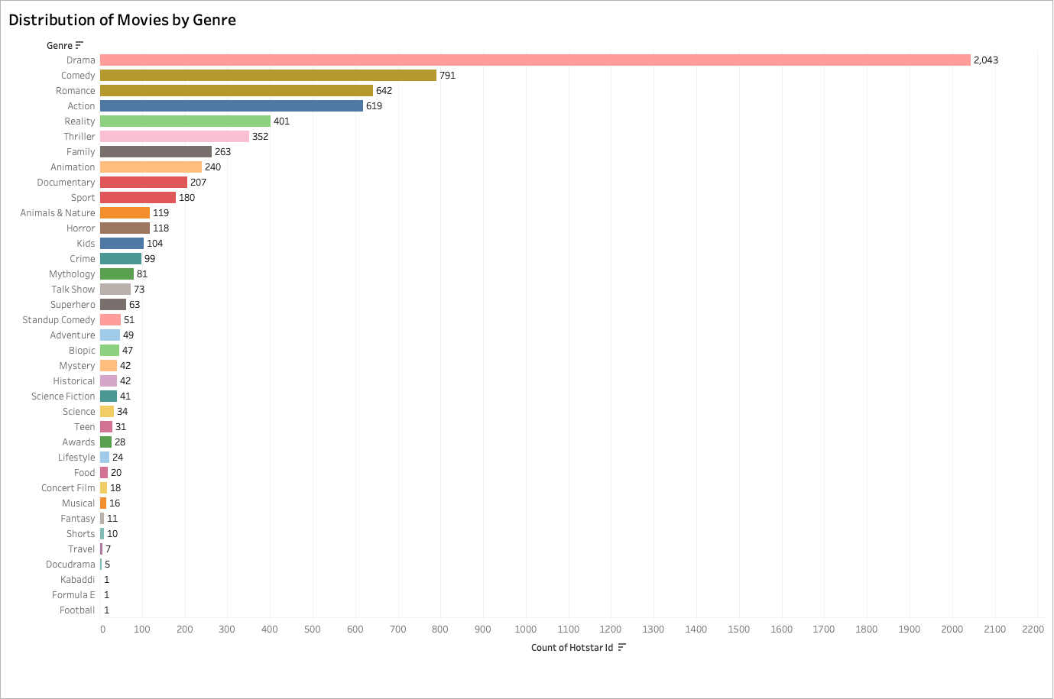

### **1. Distribution of Movies by Genre**

* **Insight**: Drama is the most dominant genre with 2,043 movies, far surpassing other genres like Comedy (791) and Romance (642). This suggests a significant skew in content production towards drama, likely driven by its broad appeal and versatility. Niche genres like Horror and Animals & Nature have very few entries, which could indicate either lower demand or limited production focus in these categories.

**Business Recommendations:**

* Focus on High-Demand Genres
* Nurture Niche Audiences
* Monitor Emerging Trends

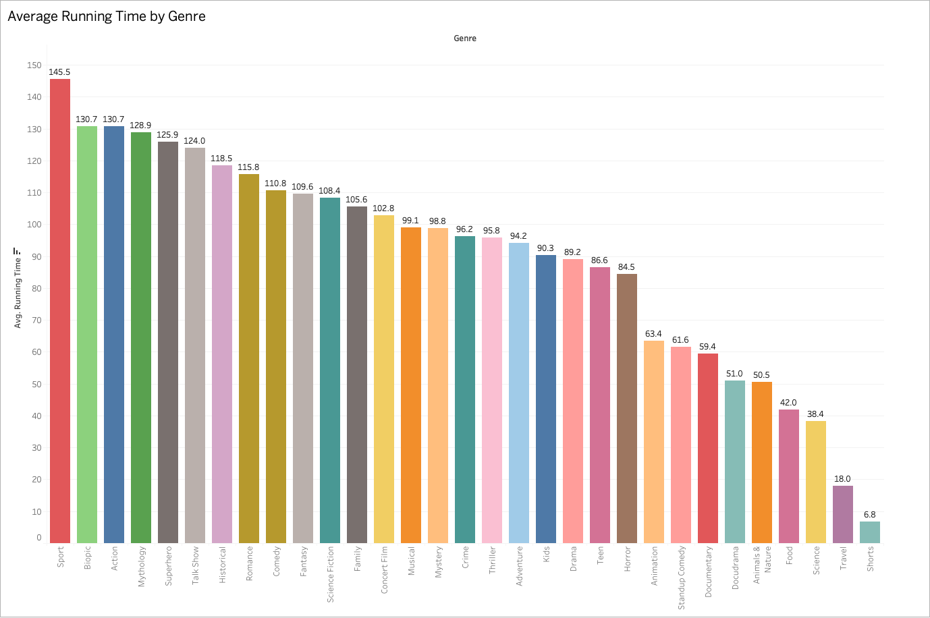

### **2. Average Running Time by Genre**

* **Insight**: The genre "Biography" has the highest average running time of 145.5 minutes, likely due to the need for extensive narrative development. In contrast, Horror and Thriller, typically focused on creating tension and excitement in a shorter timeframe, have significantly lower average running times. This variation reflects how different genres cater to different viewer expectations and storytelling needs.

**Business Recommendations:**

* Targeted Content for All Ages
* Expand Family-Friendly Content

### 

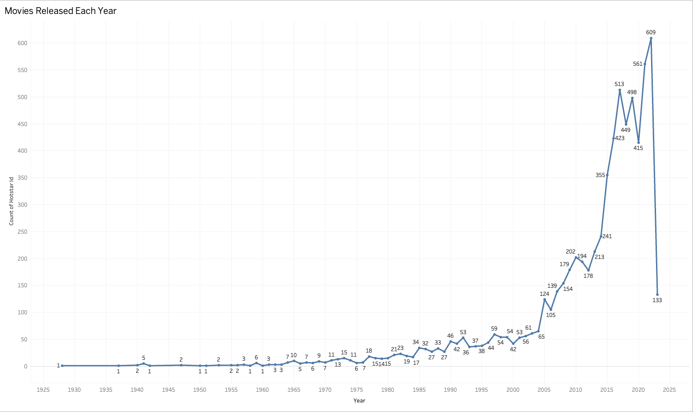

### **3. Movies Released Each Year**

* **Insight**: There is a significant spike in movie releases around 2020 with a peak of 609 films, likely driven by increased demand for content during the COVID-19 pandemic when streaming services surged. However, there's a notable decline immediately after, which could be due to production delays or shifts in content strategies post-pandemic.

**Business Recommendations:**

* Leverage Long-Running Drama
* Franchise Opportunities

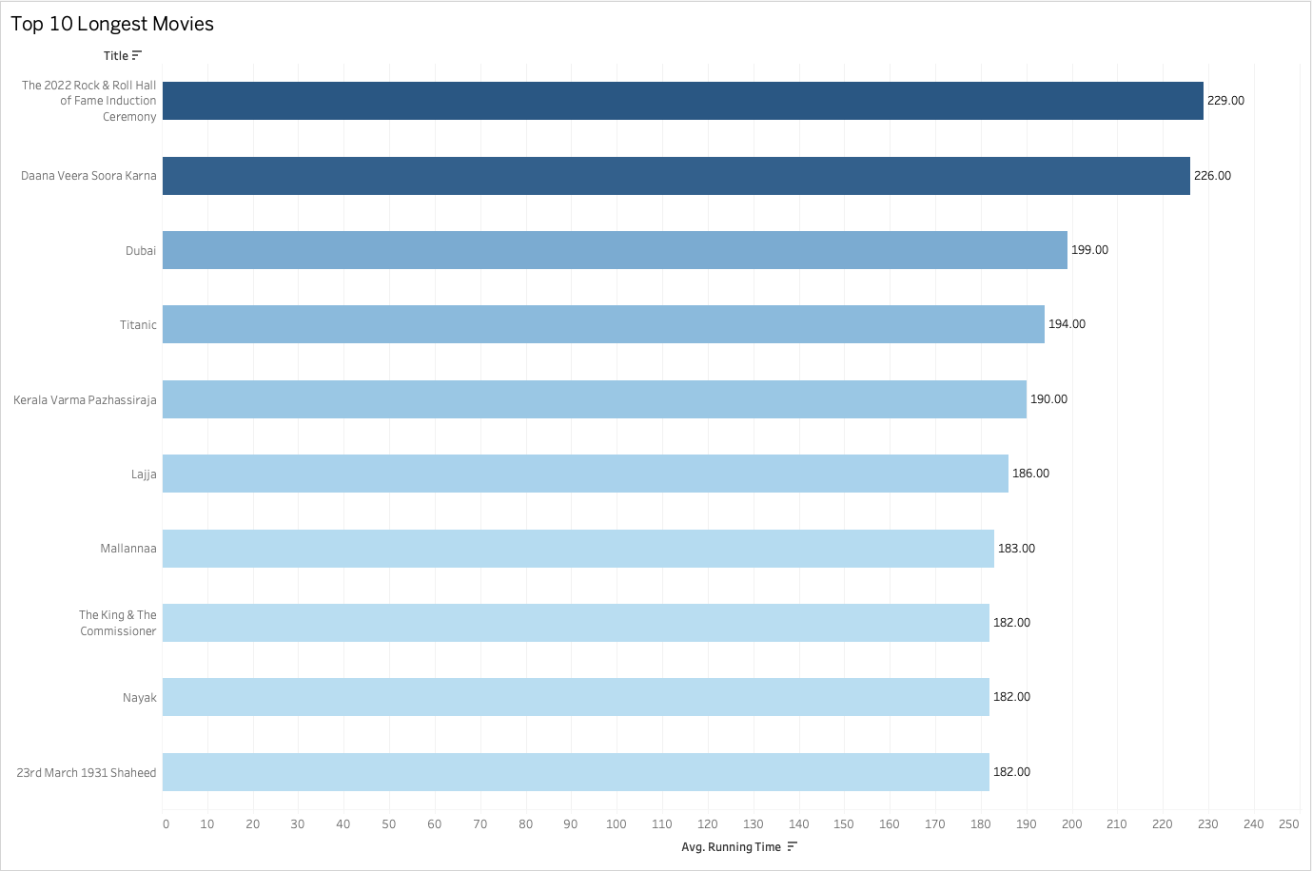

### **4.Top 10 Longest Movies**

* **Insight**: The longest movie, "The 2022 Rock & Roll Hall..." runs for 229 minutes, followed by "Daana Veera Soora Karna" at 226 minutes. Interestingly, many of the longest films appear to be historical or epic in nature (e.g., "Titanic," "Kerala Varma Pazhassi Raja"), reflecting that longer runtimes are common in films requiring detailed storytelling or period drama genres.

**Business Recommendations:**

* Focus on Full-Length Features
* Capitalise on Short-Form Content

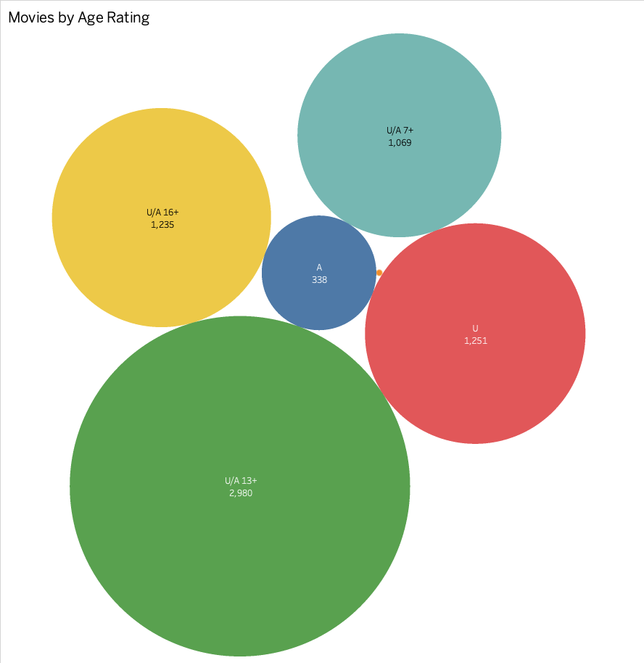

### **5.Movies by Age Rating**

* **Insight**: The largest category by age rating is U/A 13+ with 2,980 movies, followed by U with 1,251 and U/A 16+ with 1,235. This shows that a substantial amount of content is family-friendly or aimed at teenagers, possibly indicating the platform's strategy to cater to a broad age group, ensuring inclusivity across demographics.

**Business Recommendations:**

* Sustain High Content Production
* Back Catalog Strategy

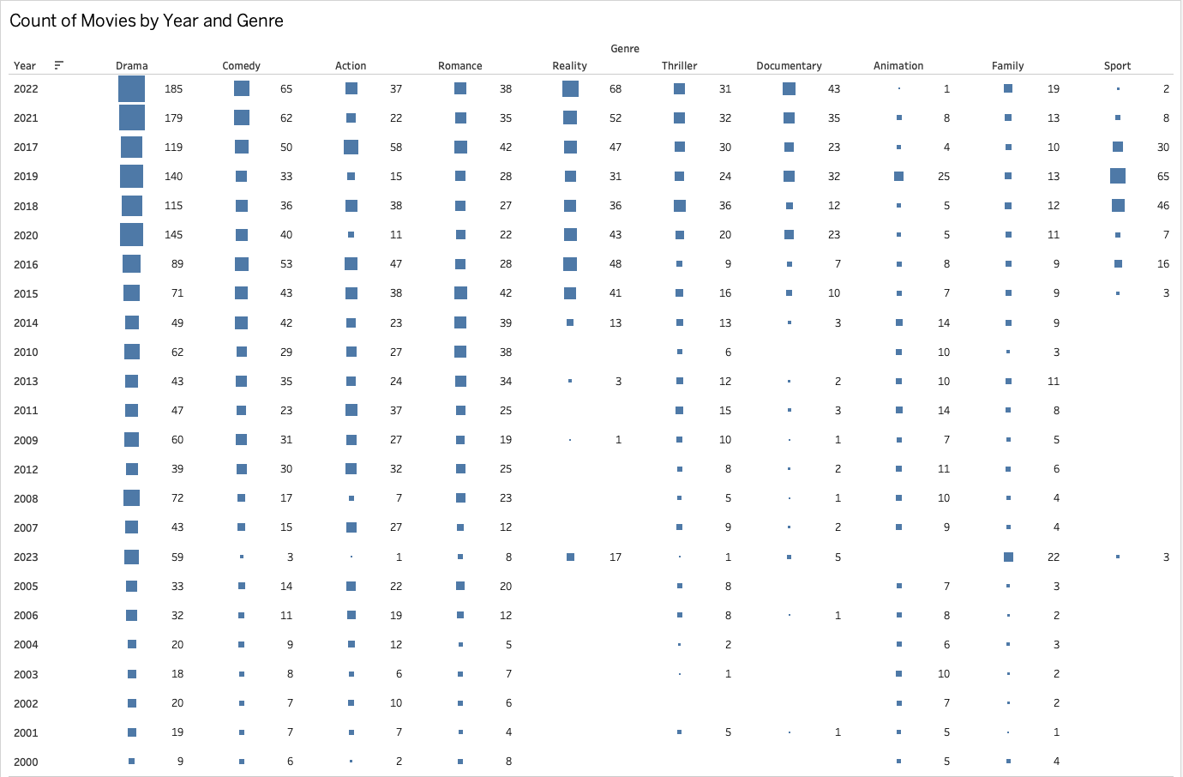

### **6.Count of Movies by Year and Genre**

* **Insight**: The count of movies released in 2022 across genres shows a notable rise in Drama and Action, with Drama being the most consistent genre over the years. The drop in movies from 2020 to 2021 aligns with global disruptions (e.g., the pandemic), reflecting how the entertainment industry adapted to significant challenges during that time.

**Business Recommendations:**

* Optimise Content by Genre
* Genre-Specific Campaigns

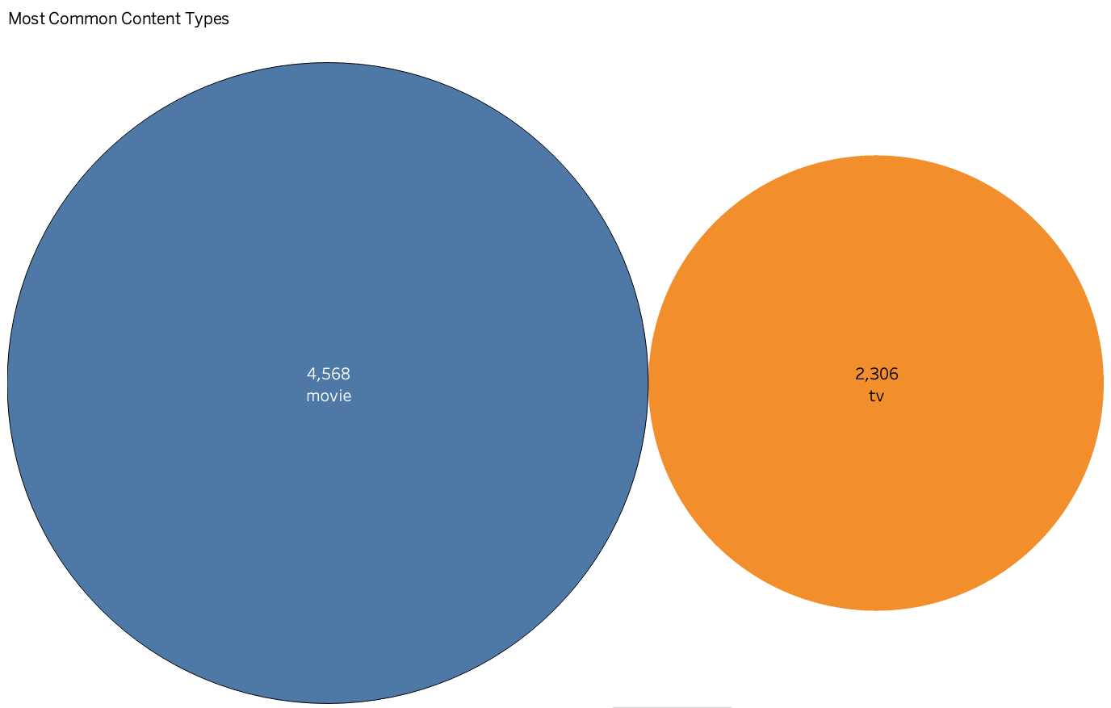

### **7.Most Common Content Types**

* **Insight**: Movies significantly outnumber TV content with 4,568 movie titles compared to 2,306 TV shows. This shows that the platform prioritises movie releases, which could indicate higher viewer engagement with movies or more resources allocated to movie production.

**Business Recommendations:**

* Balanced Age Content
* Tailored Recommendations

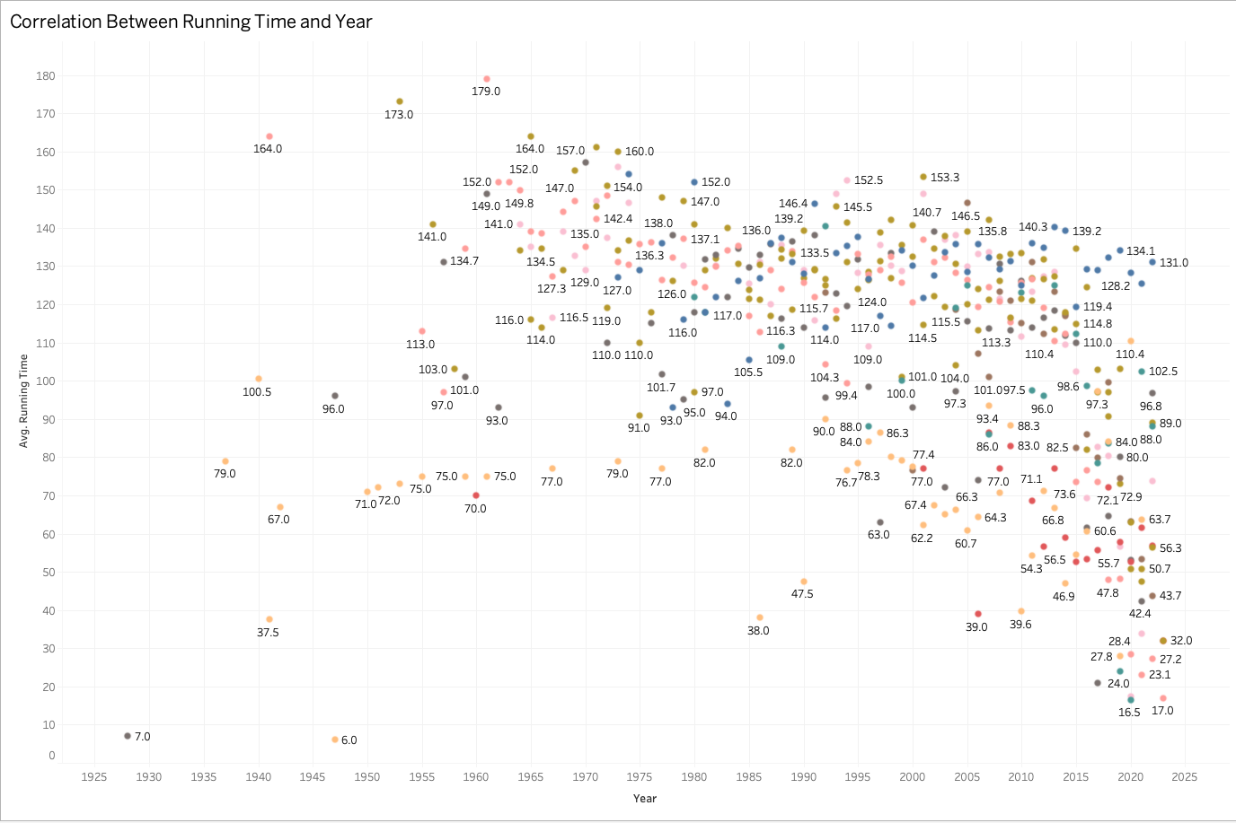

### **8.Correlation Between Running Time and Year**

* **Insight**: There’s a clear trend of movies getting shorter in running time over the years. In the earlier decades, films had much longer average runtimes, with peaks like 164 minutes in 1930. However, in recent years, movies have become significantly shorter, reflecting changing viewer preferences for more concise storytelling and perhaps more frequent releases of episodic content.

**Business Recommendations:**

* Strengthen Drama Dominance
* Diversify Other Genres

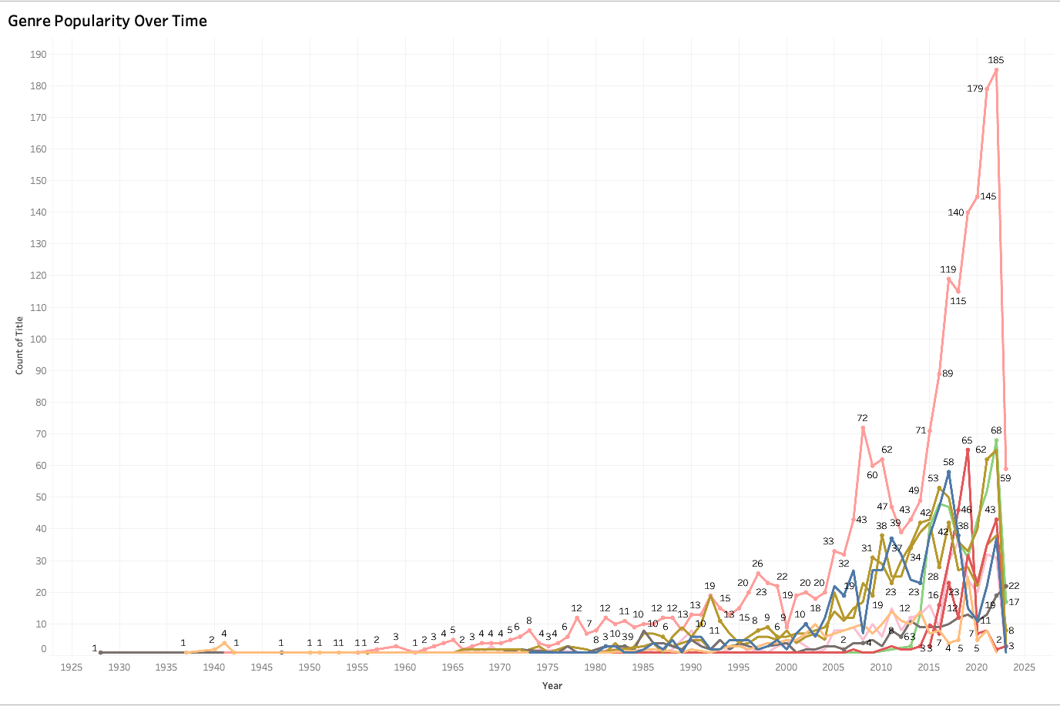

### **9. Genre Popularity Over Time**

* **Insight**: There is a sharp rise in the popularity of Drama and Reality TV post-2020, particularly in the U/A 13+ category, with Drama leading by a significant margin. This might reflect a shift towards more serious, family-oriented content, especially during the pandemic when people sought emotional and real-life connections through media. The spike in 2020 could also be due to increased production and consumption of TV content as people stayed home more during lockdowns.

**Business Recommendations:**

* Short Form for Documentaries
* Optimise Binge-Worthy Dramas

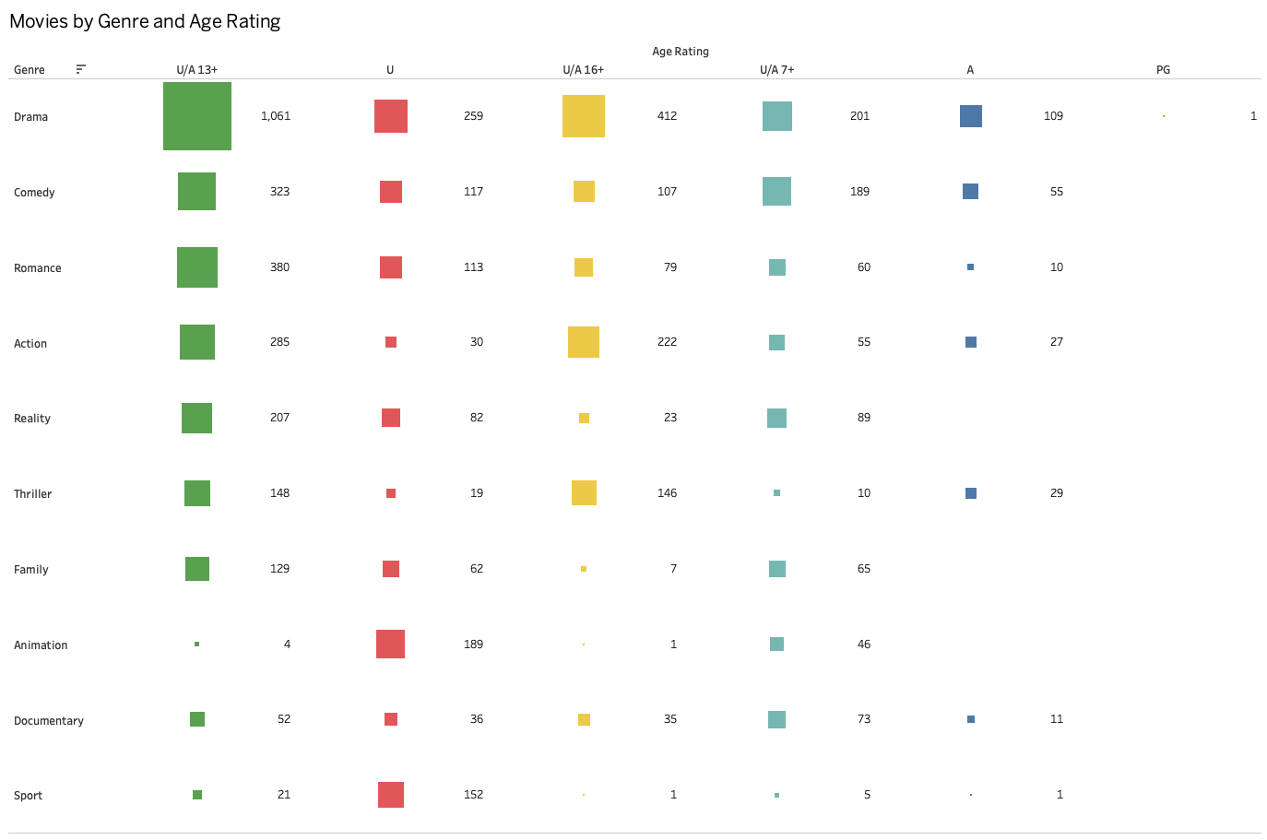

### **10.Movies by Genre and Age Rating**

* **Insight**: Drama again stands out as the most prominent genre across all age ratings, particularly for U/A 13+ (1,061 titles), which aligns with its broad appeal across different audience segments. Reality TV shows a similar pattern, though it skews more towards mature content (U/A 16+). Interestingly, genres like Action and Comedy have relatively few titles for younger audiences (U and PG), suggesting these genres tend to cater

**Business Recommendations**:

* Family-Friendly Content Expansion
* Mature Genre Focus
* Cross-Promotion

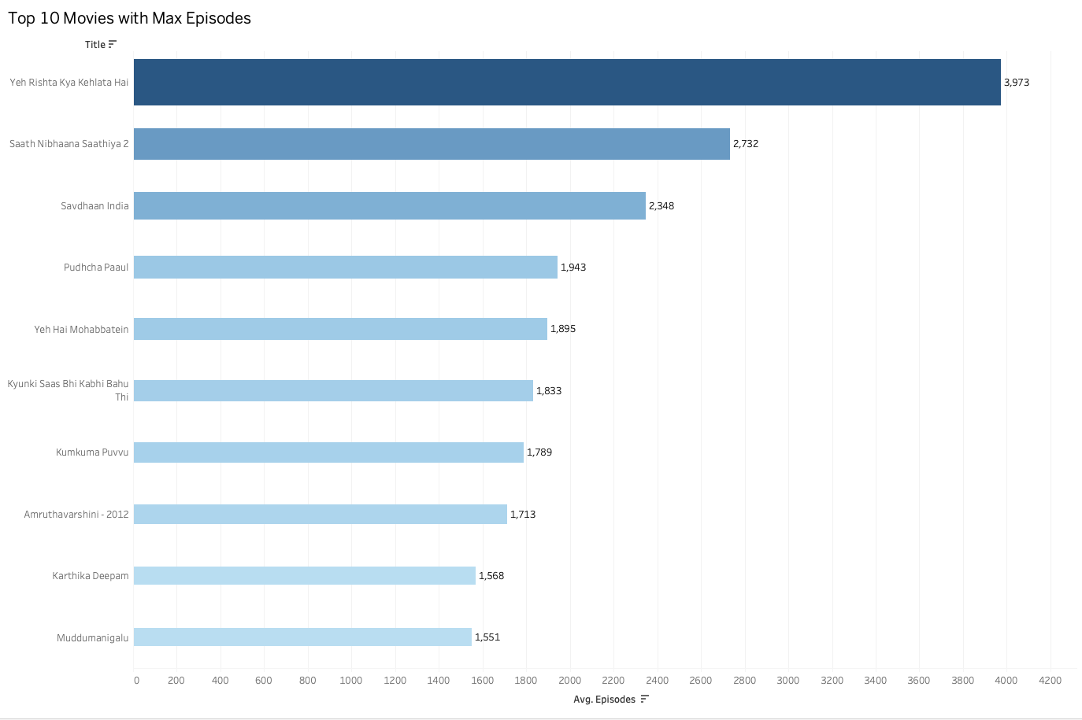

### **11.Top 10 Movies with Max Episodes**

* **Insight**: The top two shows, *Yeh Rishta Kya Kehlata Hai* and *Saath Nibhaana Saathiya 2*, dominate the list, with over 3,900 and 2,700 episodes respectively. This reflects the Indian TV audience’s preference for long-running soap operas, often spanning years or even decades. These shows likely focus on family dynamics and social themes, which resonate well with viewers, ensuring their longevity. Shorter shows, like *Muddugangalu* and *Karthika Deepam*, still manage to secure a dedicated following despite having fewer episodes.

**Business Recommendations**:

* Expand Long-Running Content
* Create Spin-offs
* Focus on Regional Content

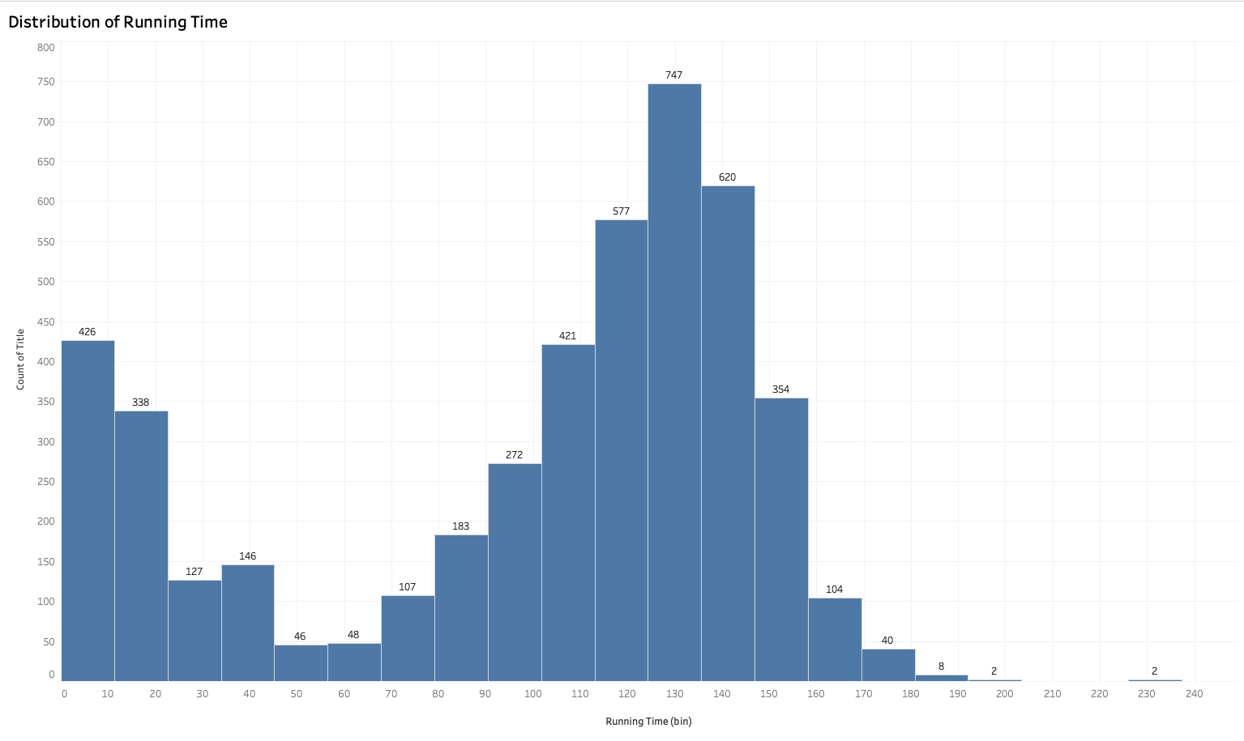

### **12. Distribution of Running Time Chart**

This chart shows the distribution of movie runtimes on Disney+ Hotstar, indicating the most common duration ranges for content on the platform. Key observations include:

* **Short Films (0-20 minutes):** A significant portion of titles fall in this range, with **426 titles** running 0-10 minutes and **338 titles** running 10-20 minutes. This suggests a focus on short-form content, such as mini-episodes, web shorts, or other quick-view formats.
* **Moderate-Length Films (90-130 minutes):** The majority of titles cluster around the **90-130 minute** mark, peaking at **120-130 minutes** with **747 titles**. This range is the traditional length for full-length feature films and aligns with the common runtime for mainstream cinema.
* **Extended-Length Films (150-170 minutes):** A smaller but still significant portion of movies falls in the **150-160 minute** category, indicating that some longer-form content is available, likely in the form of epic films or specials.
* **Very Long Films (170+ minutes):** A minimal number of films exceed the **170-minute mark**, suggesting that extra-long films are rare on the platform. This indicates that Disney+ Hotstar doesn't generally cater to an audience that prefers very long narratives.

**DASHBOARDS**

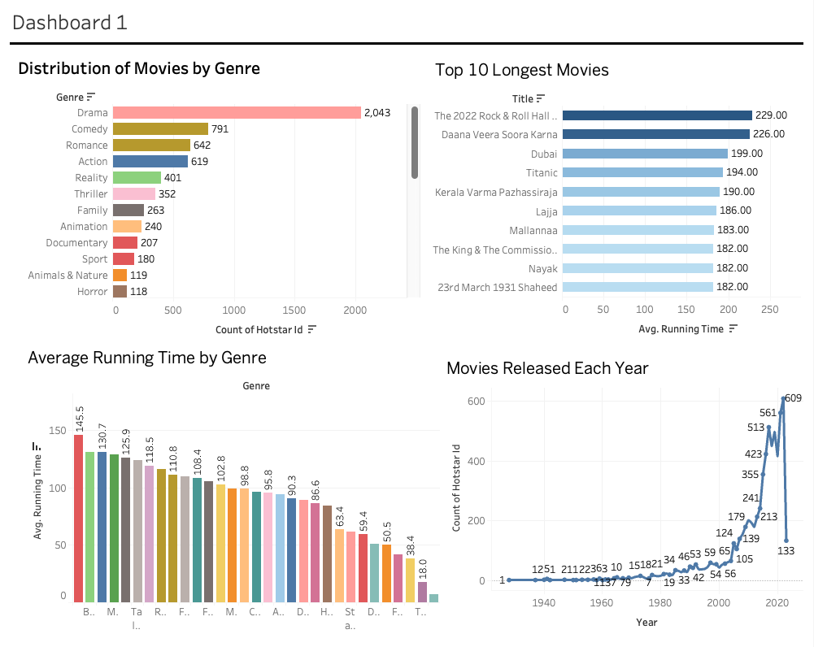

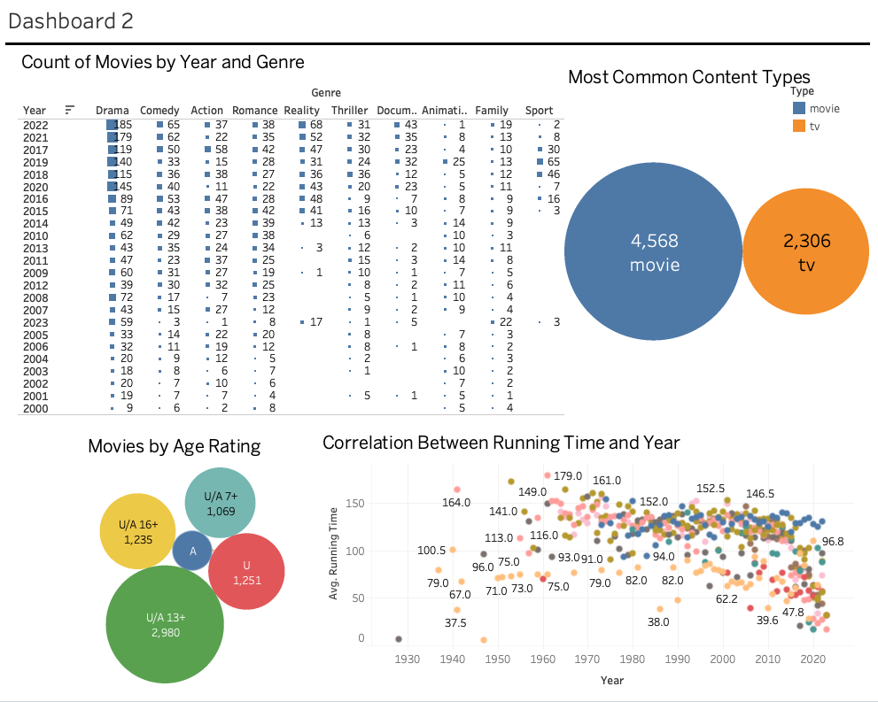

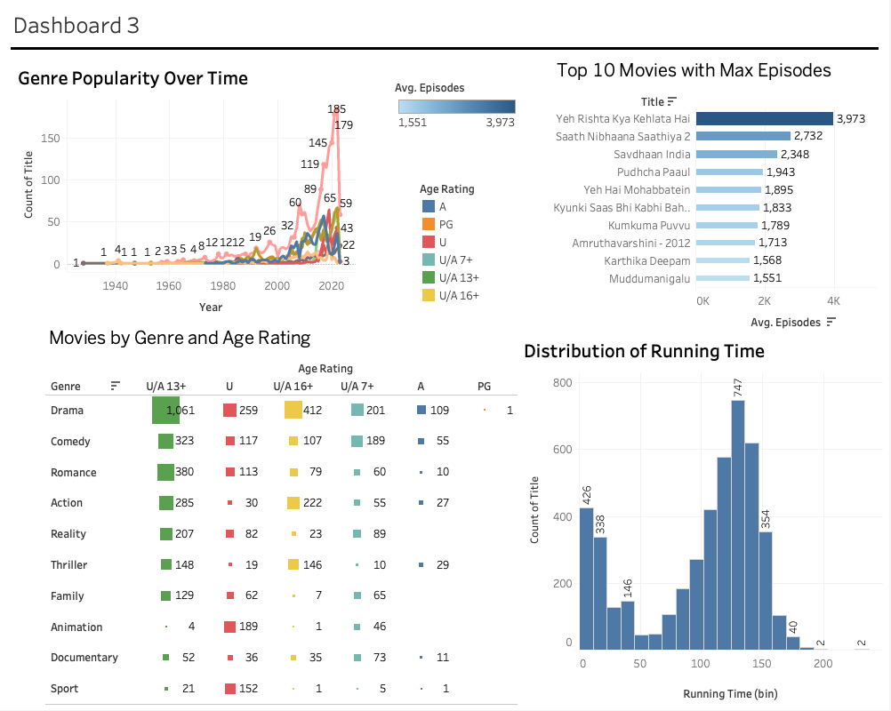

### **Comprehensive Business Recommendations for Disney+Hotstar**

Based on the analysis of the Disney+ Hotstar movie dataset, several strategic recommendations can be made to help the platform enhance its content offerings, attract a wider audience, and optimise its overall performance. The following recommendations are divided into key areas of focus: **Content Strategy**, **Audience Segmentation**, **Marketing Campaigns**, and **Operational Strategy**.

### **1. Content Strategy: Focus on Drama and Emerging Genres**

#### **Leverage the Dominance of Drama**

From the dataset, Drama is the leading genre in terms of the number of titles and popularity across all age ratings, especially U/A 13+. The sharp rise in Drama releases post-2020 indicates that it resonates well with audiences, particularly during times of uncertainty (e.g., the COVID-19 pandemic).

* **Recommendation**: Increase investment in producing and acquiring high-quality Drama content. Ensure that content in this genre covers a variety of subthemes (family, relationships, social issues) to appeal to a broad audience base. Focus on building franchises within this genre to create long-term viewer loyalty.

#### **Expand Niche Genres: Action, Thriller, and Documentary**

Genres like Action, Thriller, and Documentary, though less represented, offer significant potential for growth. The platform could diversify its portfolio to attract viewers with different tastes and preferences.

* **Recommendation**: Gradually expand the offerings in niche genres such as Action and Thriller to cater to a mature audience (U/A 16+ and A ratings). Promote high-impact documentaries, especially in the U/A 7+ and U/A 13+ age ratings, as these can capture audiences interested in real-life stories and education.

#### **Capitalise on Shorter Running Times**

The trend towards shorter movie runtimes aligns with modern viewing habits where viewers prefer concise storytelling. The majority of the movies in the dataset have runtimes between 100-120 minutes.

* **Recommendation**: Focus on creating content with shorter running times (90-120 minutes) to cater to modern audience preferences. Miniseries or limited-episode shows can also be explored to ensure viewers remain engaged without being overwhelmed by lengthy narratives.

### **2. Audience Segmentation: Target Key Demographic Groups**

#### **Focus on U/A 13+ Family Content**

The U/A 13+ category dominates the dataset, indicating that family-friendly content has the widest reach and highest engagement. Drama, Comedy, and Reality TV are the top-performing genres in this age group.

* **Recommendation**: Develop content that appeals to families, particularly in the Drama and Reality genres. Explore creating interactive family-based shows or quizzes that encourage co-viewing among multiple family members. This can increase user engagement and retention.

#### **Diversify Content for Mature Audiences**

While U/A 13+ dominates, there is also a growing audience for mature content in the U/A 16+ and A categories. Genres such as Action, Thriller, and Drama resonate well with these viewers.

* **Recommendation**: Invest in bold, mature themes targeting the U/A 16+ and A segments. This can include action-packed thrillers, psychological dramas, and content addressing adult issues such as politics, crime, or social controversies.

#### **Localised Content for Regional Markets**

Based on the popularity of specific long-running shows in local languages (*Yeh Rishta Kya Kehlata Hai* and *Saath Nibhaana Saathiya 2*), there’s significant demand for localised content that reflects cultural and regional nuances.

* **Recommendation**: Continue producing region-specific content in local languages, while expanding into underserved regions or languages. Collaborating with regional film industries can help produce high-quality, culturally relevant content.

### **3. Marketing Campaigns: Data-Driven, Audience-Specific Targeting**

#### **Leverage Popular Long-Running Shows**

Long-running TV series such as *Yeh Rishta Kya Kehlata Hai* and *Saath Nibhaana Saathiya 2* have a massive number of episodes and are well-entrenched in viewer habits. These shows contribute significantly to user retention and sustained engagement.

* **Recommendation**: Build marketing campaigns around popular, long-running shows to reinforce the platform's strength in delivering consistent, engaging content. Highlight special episodes, milestones, or cast reunions to drive interest.

#### 

#### 

#### **Use Genre-Specific Marketing for Audience Segmentation**

Different audience groups prefer different genres (e.g., Drama for U/A 13+ and Action/Thriller for U/A 16+). Understanding these preferences allows Disney+ Hotstar to tailor marketing efforts.

* **Recommendation**: Segment the audience by genre preferences and deploy genre-specific marketing campaigns. For instance, promote Drama series to family-oriented viewers, while targeting Action and Thriller content toward adult demographics using social media, email, and targeted ads.

#### **Seasonal Campaigns and Content Release**

There was a noticeable spike in the number of movie releases during 2020, coinciding with global lockdowns. This indicates that releasing high volumes of content during periods when people spend more time at home (e.g., holidays, long weekends) can yield higher engagement.

* **Recommendation**: Time major content releases around holidays, weekends, or global events when people are more likely to stream content. Collaborate with influencers or celebrities to promote exclusive holiday specials or premieres.

### **4. Operational Strategy: Optimise Content Production and Licensing**

#### **Invest in Exclusive Content and Originals**

With the sharp rise in Drama and Reality TV content, investing in exclusive originals and high-quality licensed content is essential for maintaining a competitive edge.

* **Recommendation**: Double down on original content production to create a unique value proposition. Disney+ Hotstar Originals should focus on high-performing genres like Drama, Family, and Reality, while introducing fresh takes on Action and Thriller.

#### **Leverage Analytics for Viewer Retention**

Analysing viewer data and consumption patterns can help the platform better understand user engagement and anticipate preferences.

* **Recommendation**: Use machine learning and advanced data analytics to personalise recommendations based on viewers’ watching habits. Segment users based on frequency of engagement, preferred genres, and age ratings to ensure content recommendations are highly relevant and personalised.

#### 

#### 

#### 

#### **Adapt to Global and Regional Trends**

The rise in localised content consumption is apparent, especially with the success of regional, long-running series. Additionally, global trends like shorter runtime preferences and genre-specific content demand reflect the evolving media consumption landscape.

* **Recommendation**: Continuously monitor both global and regional content trends to adapt quickly to shifts in viewer preferences. For example, expand globally popular genres such as Action and Drama while maintaining regional authenticity through local content partnerships.

### **Conclusion**

Disney+ Hotstar is well-positioned to continue growing by leveraging its strong catalogue of popular genres like Drama, focusing on key audience segments, and expanding its portfolio in underrepresented genres. By fine-tuning content strategy, tailoring marketing efforts, and optimising content production, Disney+ Hotstar can enhance its market share and audience retention in the highly competitive streaming industry. Emphasising shorter running times, regional content, and mature-themed genres will ensure the platform appeals to a wide variety of viewers, from families to adult audiences. Strategic investment in originals and data-driven personalization will further solidify its standing as a go-to streaming service in India and globally.

THANKYOU